Instruction for safety during soldering and disclaim liability.

Make sure credit Digispark and Digistump and dissociate from them that this is not their product, and they do not provide support.

Instruction for assembly of owlboard

Copy how it was done in the pic32 version of this board, but update for attiny84

Instructions for use owletBoard v5 software

Remmeber to tell user multiple times we are not responsible for their damaged stuff.

Owlet v5 use ATTINY84 chip

Give pinout to user here.

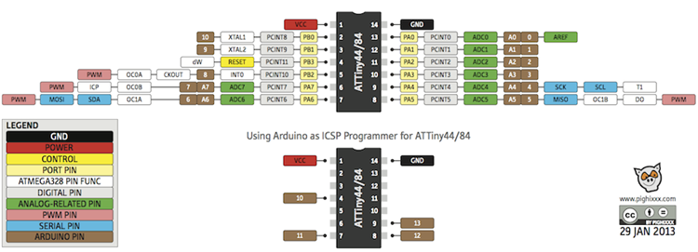

Put pic of board and outline pins that you can use. Explain RGB led. Tell what D2, D1, and D3 are connected to plus S1 and S2. Explain S1 S2 pull up or pull down.

How to install

1. Install Arduino
2. Go to file > Preferences.
3. Under Additional Boards Manager URL type: <https://raw.githubusercontent.com/kevin-oit/owletBoard_attiny84/master/package_oregontech_owletboard_index.json>
4. Go to Tools > Boards > Board Manager
5. Type owl into the menu bar and you should see owlet Boards by owletBoard. Click install.
6. Download this file: <https://github.com/kevin-oit/owletBoard_attiny84/blob/master/micronucleus_for_owlboard_0.1-win.zip>
7. Unzip it and use it to install the drivers. Remember, Must plug digispark in 5 seconds and install really fast because USB only stays connected for 5 seconds.
8. When install drivers, go to windows_driver_installer folder and right click run as admin on zadig_2.1.2.exe
9. When screen come on, select unknown usb device real fast and click install.
10. Wait for success.

Use instructions from <https://learn.sparkfun.com/tutorials/how-to-install-an-attiny-bootloader-with-virtual-usb#resources-and-going-further>

How to write code to

1. Blink LED?

Remember to tell user to go to Tools > Boards > Oregon tech Owletboard > OwletBoard (ATtiny84,3.3V 8MHz)

Remember to tell user to unplug and plug when the window prompts them to. It is normal to see USB device unknown after, since the microcontroller turns off the USB after programming and enters user code mode.

1. PWM LED? Idk. Do something else.
2. Configure a button
3. Configure serial?

More information

Make sure explain user this not normal Arduino, may need use different pins. This device have limited memory and MHz. Can try digistump libraries included but not guarantee to work.

How to program

1. Press the compile and upload button
2. Plug in digispark when asked to do so
   1. Make sure to disclaim all legal liability.
3. Windows will error with USB device but is ok.

Use material from:

From <https://digistump.com/wiki/digispark/tutorials/connecting>

and <https://learn.sparkfun.com/tutorials/how-to-install-an-attiny-bootloader-with-virtual-usb#resources-and-going-further>

to fill in the rest.